

SIMATS ENGINEERING

Saveetha Institute of Medical and Technical Sciences
Chennai- 602105

Student Name: SHABARISH N Reg. No: 192424007
Course Code: CSA1711 Slot: C
Course Name: ARTIFICIAL INTELLIGENCE
Course Faculty: Dr. Krishna Kumar Kathiresan
Project Title: SMART TRAFFIC DENSITY PREDICTION CCTV-Based Vehicle Detection and Congestion Forecasting using YOLO, CNN & LSTM
Module Photographs:
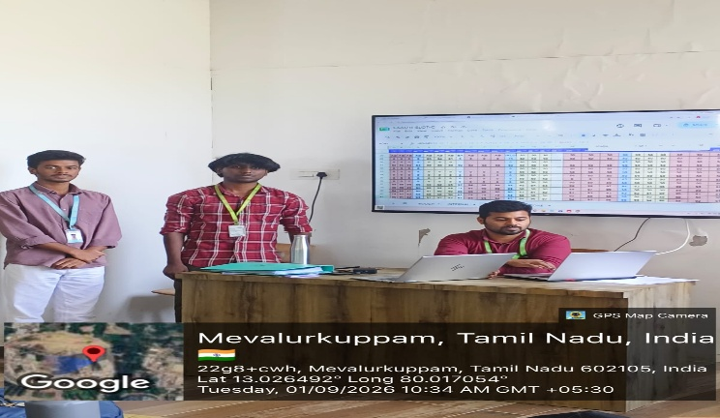
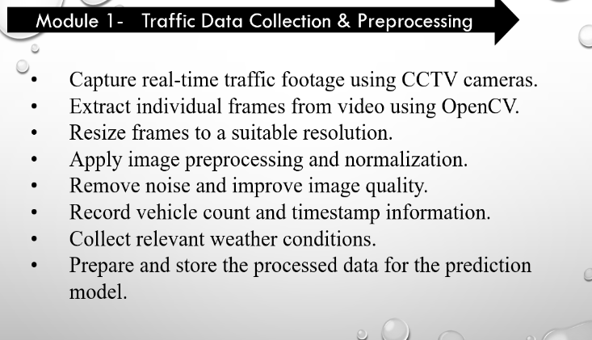
Project Description:
This project is a smart traffic monitoring and congestion prediction system developed using Python and deep learning techniques. The system uses CCTV traffic footage as input and analyzes the video frame by frame to identify different types of vehicles such as cars, buses, trucks, and motorcycles. YOLO (You Only Look Once) is used for fast and accurate vehicle detection and counting, while CNN is used to extract important visual features from traffic scenes. To predict future traffic conditions, LSTM (Long Short-Term Memory) is used to study traffic patterns over time and forecast upcoming congestion levels. Graphs and traffic statistics can also be displayed for better understanding of changing traffic conditions. Overall, the project combines YOLO, CNN, and LSTM to provide both real-time traffic analysis and future congestion forecasting, making it useful for smart city traffic monitoring and management.counts, the combination of YOLO, CNN, and LSTM allows the system to perform both real-time traffic analysis and future congestion forecasting. Overall, this project demonstrates a complete end-to-end Artificial Intelligence and Deep Learning workflow — from CCTV video acquisition and vehicle detection to traffic density estimation, temporal pattern analysis, congestion prediction, and dashboard-based visualization — making it a practical solution for intelligent traffic monitoring and Smart City traffic management.

Student Signature Guide Signature

